Remote Learning 6W
Remember to read your book every day for at least 20 minutes, and practice and recall your times tables daily.
Recording of work: If you have your Exercise books at home, please record the suggested activities in these.
If you do not, please record on paper or on MS Word. Don’t forget to upload completed work to your class teacher, via MS TEAMS using your personal log in

 | Week beginning: 4.1.21
Maths | This week we are looking at Fractions: addition  Please look at the “Do It”, “Stretch It” & “Solve It” questions and aim to complete one set each day.
Guided Reading | We will aim to get a copy of “The Hobbit” to you. Or, you may wish to download the kindle edition, as we will be using this for Reading, Writing and DEAR time.  Think about the following vocabulary in Chapter 2. After you have read the chapter, match the words to their definitions:  dismally Absolutely essential or necessary  defrayed A procession of people – usually on horseback  requisite Bound to do something – sometimes as a favour  dreary Gloomily, in a depressed way  obliged Provided money for costs or expenses  cavalcade Sad, dull, boring
Writing | OUR WRITING THIS TERM WILL BE BASED ON “THE HOBBIT”  As an introduction, think about what you know about the story – whether from what we have read together or your own knowledge of the book/films. Write a short “blurb” to describe the story.
Spelling | 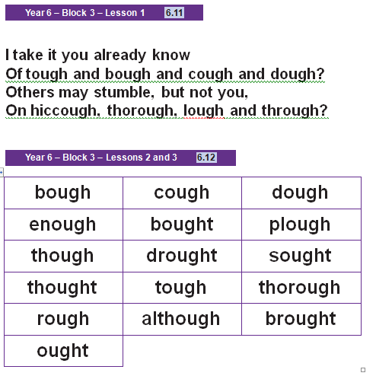  Check that you know how to pronounce all these weird and wonderful ‘ough’ words!  Use one of our No Nonsense Spelling strategies to help you rehearse and remember this week’s words. Use our school website if you need help remembering them: https://hardwicke-parochial.eschools.co.uk/web/english/501701
Topic/Science | SCIENCE: This term we are continuing to learn about the Human Anatomy, specifically the heart. Please visit this website and complete one activity a week, whilst you are at home: https://classroom.thenational.academy/units/human-anatomy-f968  GEOGRAPHY: Our new geography topic is all about ‘Natural Disasters’. Please visit this website and complete one activity a week, whilst you are at home: https://classroom.thenational.academy/units/water-weather-and-climate-4454  PSCHE: Whilst you are isolating at home, it is important you keep safe. Please visit this website and complete one activity a week, whilst you are at home: https://classroom.thenational.academy/units/keeping-safe-2054

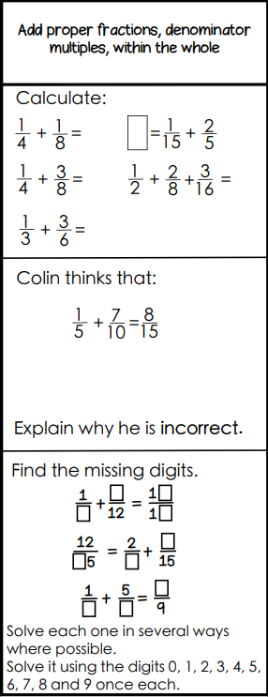  Tuesday 5th January 2021 | 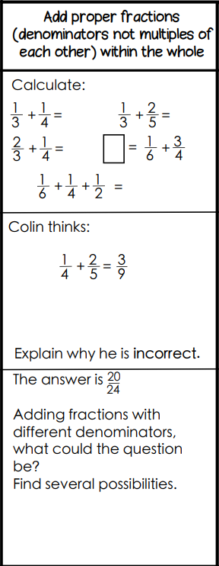  Wednesday 6th January 2021 | 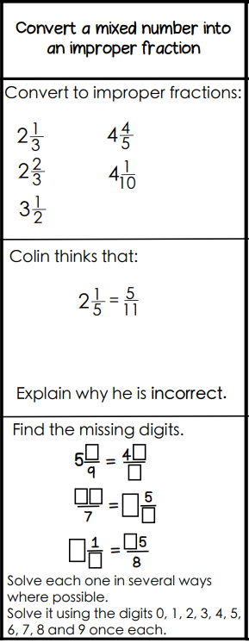  Thursday 7th January 2021 | 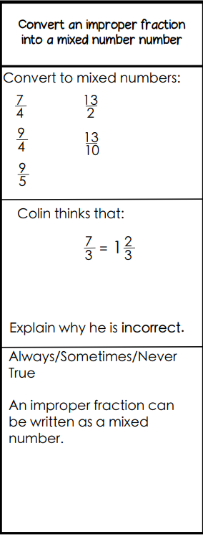  Friday 8th January 2021

