DATE 05/01/21 | How am I doing?
Area of Maths |  | Teacher | Me
Build the 11x table and count in steps of 11 from zero | Do it
 | Stretch it
 | Solve it
Do it  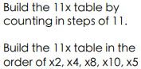  Stretch it  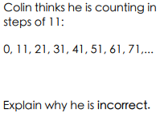  Solve it  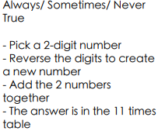 |  |  |  | Do It
 |  |  |  | Stretch It
 |  |  |  | Solve it

